Sofía Belén López No. 1104822

TAREA 4

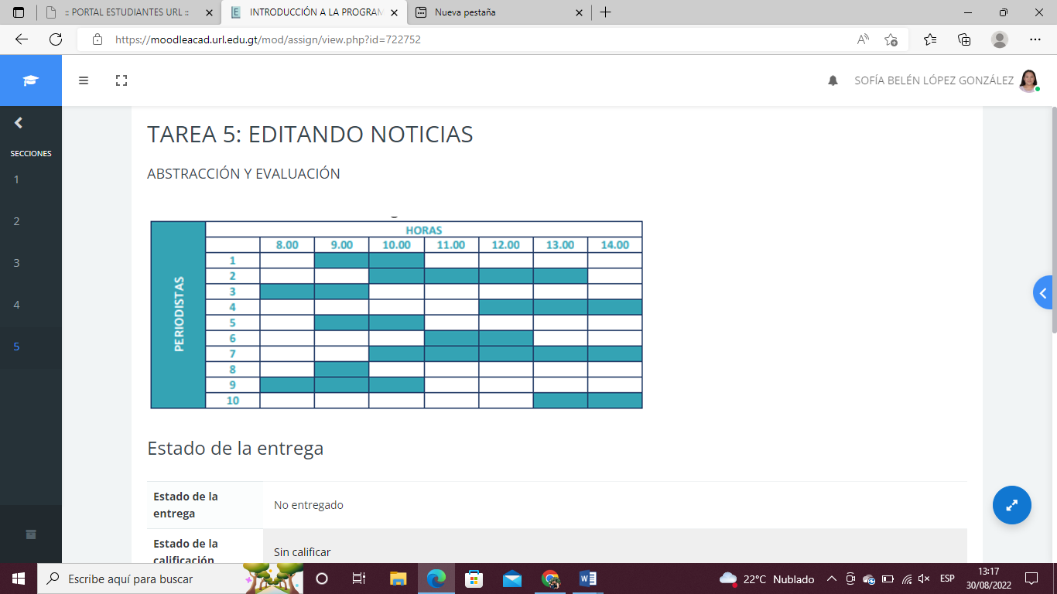

|  |  |  |  |  |  |  |  |
| --- | --- | --- | --- | --- | --- | --- | --- |
|  | 8:00 | 9:00 | 10:00 | 11:00 | 12:00 | 13:00 | 14:00 |
| 1 |  | PC 1 | PC 1 |  |  |  |  |
| 2 |  |  | PC2 | PC 1 | PC 1 | PC 1 |  |
| 3 | Pc 1 | PC 2 |  |  |  |  |  |
| 4 |  |  |  |  | PC 2 | PC 2 | PC 1 |
| 5 |  | PC 3 | PC 3 |  |  |  |  |
| 6 |  |  |  | PC 2 | PC 3 |  |  |
| 7 |  |  | PC 4 | PC 3 | PC 4 | PC 3 | PC 2 |
| 8 |  | PC 4 |  |  |  |  |  |
| 9 | PC 2 | PC 5 |  |  |  |  |  |
| 10 |  |  |  |  |  | PC 4 | PC 3 |

El número máximo de PC son 5.